ODISHA Circle Conference View of DIAS
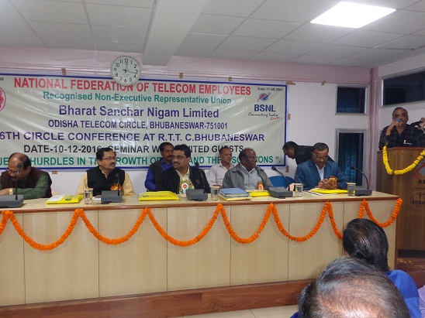
ODISHA Circle Conference View of Audience
